Word Document Template (Heading 1)
  - Last Updated: October 14, 2022 (subtitle or caption)

The College of Arts and Sciences Office of Marketing and Communications has created and approved the template that adheres to brand and accessibility standards. To ensure consistency, all must use this template to create your Word documents.

Below you’ll find the heading structures.

Categories/Headings (Heading 2)
Here are important tips to keep in mind when creating an accessible Word document.
- There should only be one Heading 1 on a document. Heading 1 acts like a title of the document.
- Example of “Normal” body text that is Arial font at 11-point size and the color is Putnam Gray (see page 4 to learn how to create this custom color).
- Other heading levels
  - Heading 2
  - Heading 3
  - Heading 4
  - Heading 5
  - Heading 6
- You cannot skip a heading level, meaning, you can’t go from a Heading 1 to a Heading 3.

Sub Category (Heading 3)
More Normal Body Text

Sub Category within the Sub Category (Heading 4)
More Normal Body Text

If you need more headings (Heading 5)
More Normal Body Text

Even More Heading (Heading 6)
More Normal Body Text

How to set up a branded word document
- Open up this document
- Place your curser on the Heading 1 at the top of this document
- Then head over to your “styles” section.
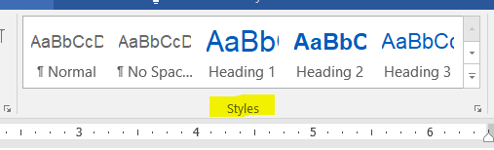
- Right-click on Heading 1 and select “Update Heading 1 to Match Selection”
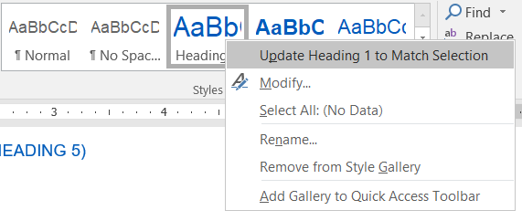
- Right-click on Heading 1 again and select “Modify”
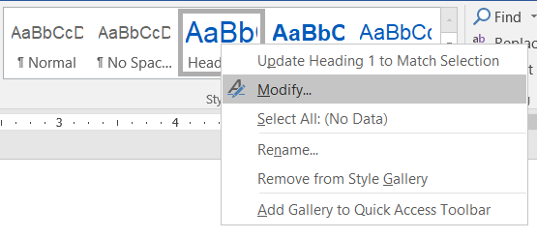
- Check to make sure that your Heading 1 has the following:
- Font: Arial
- Font size: 24
- Font Color: UB Blue (see below to learn how to change font color)
- Check “Automatically update” and “New document based on this template.”
*Everytime you open a new Word document, it will be brand compliant.
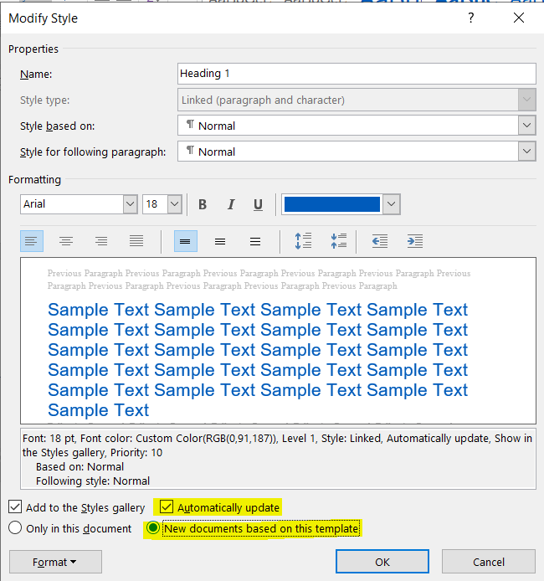
- Then, click “OK”
- Next, repeat with each of the Normal body text and other headings

How to check for UB brand font colors.
- Go back and “modify” the heading
- Click the font color drop-down menu and click “More Colors…”
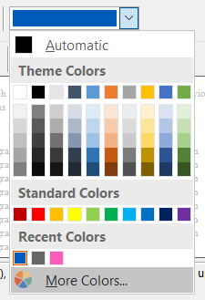
- Make sure you’re on the “Custom” tab and update the red, green and blue to match the numbers that you can find below to create the UB colors.
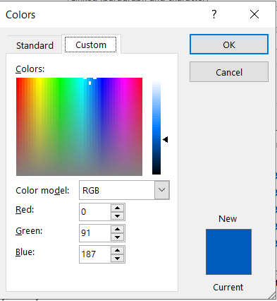
- Then, click “OK”

UB Colors
The follow color are brand compliant and accessible to use.

UB Blue
- R=0
- B=91
- G=187

Putnam Gray
- R=102
- G=102
- B=102
Harriman Blue
- R=0
- G=47
- B=86

Niagara Whirlpool
- R=0
- G=101
- B=112

